Assignment No 3
GHAZI UNIERSITY D.G KHAN
Subject:
“ Programming Fundamentals lab 3”
Submitted By:
Name: “ Sadia Shamroze”
Class: “ BS Computer Science ”
Section : “ C ”
Submitted To:
“ Prof. Asad Majeed “

TASK 1
Assume that the following variables are defined:
int age;
double pay;
char section;
Write a single cin statement that will read input into each of these variables.
Handwritten Code

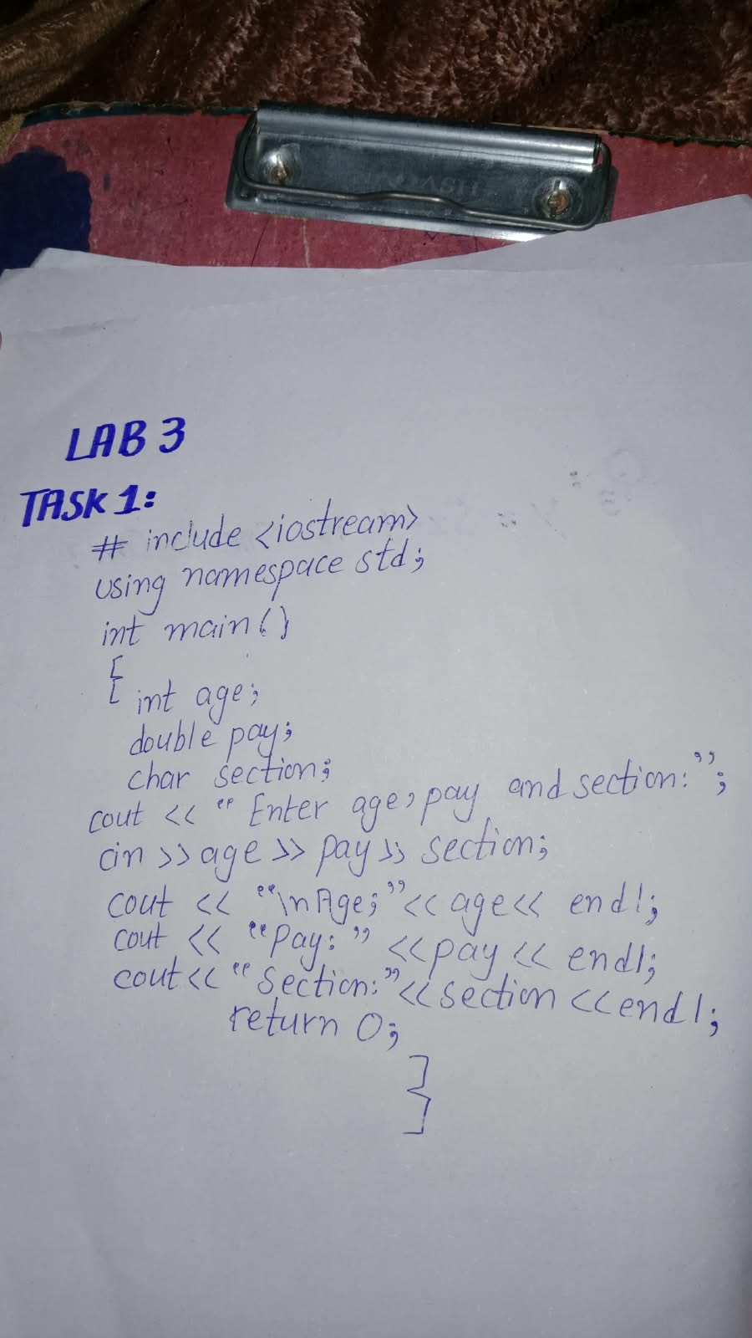
Program Written on desktop/Phone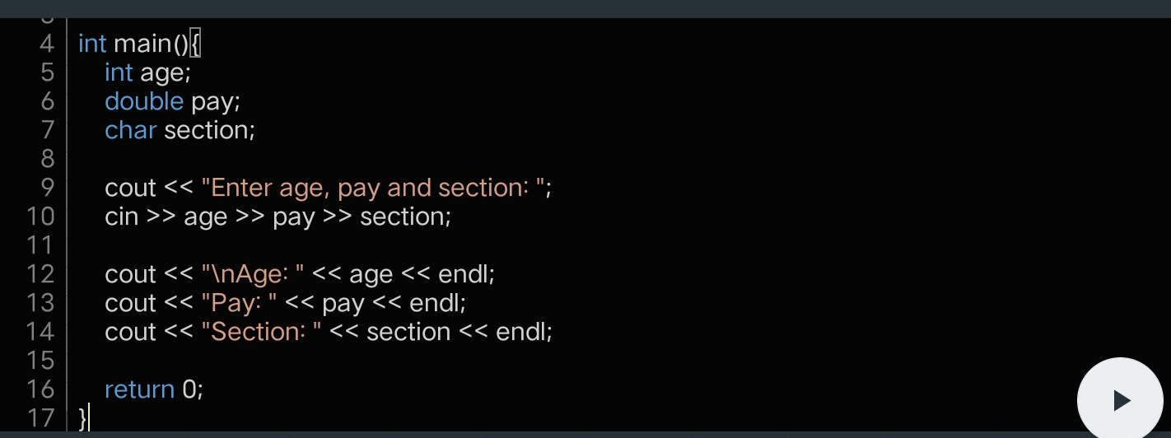
Code Output
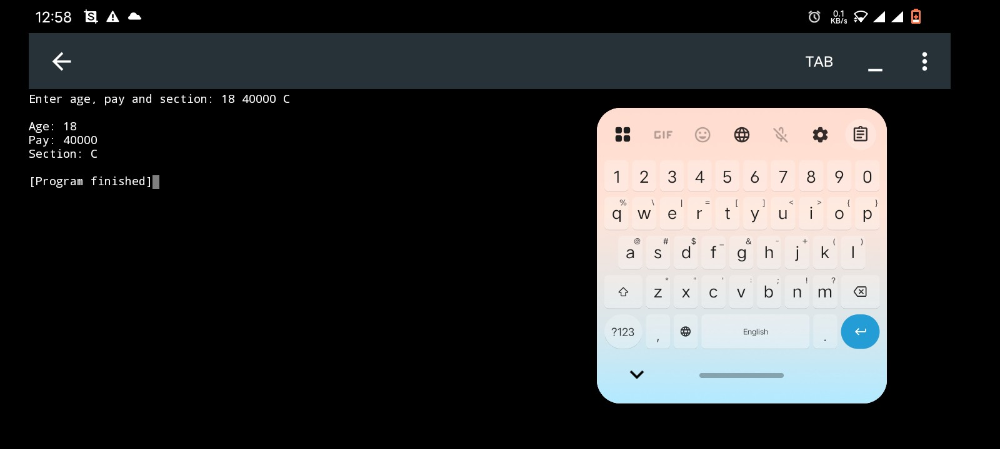
TASK 2
Handwritten Code
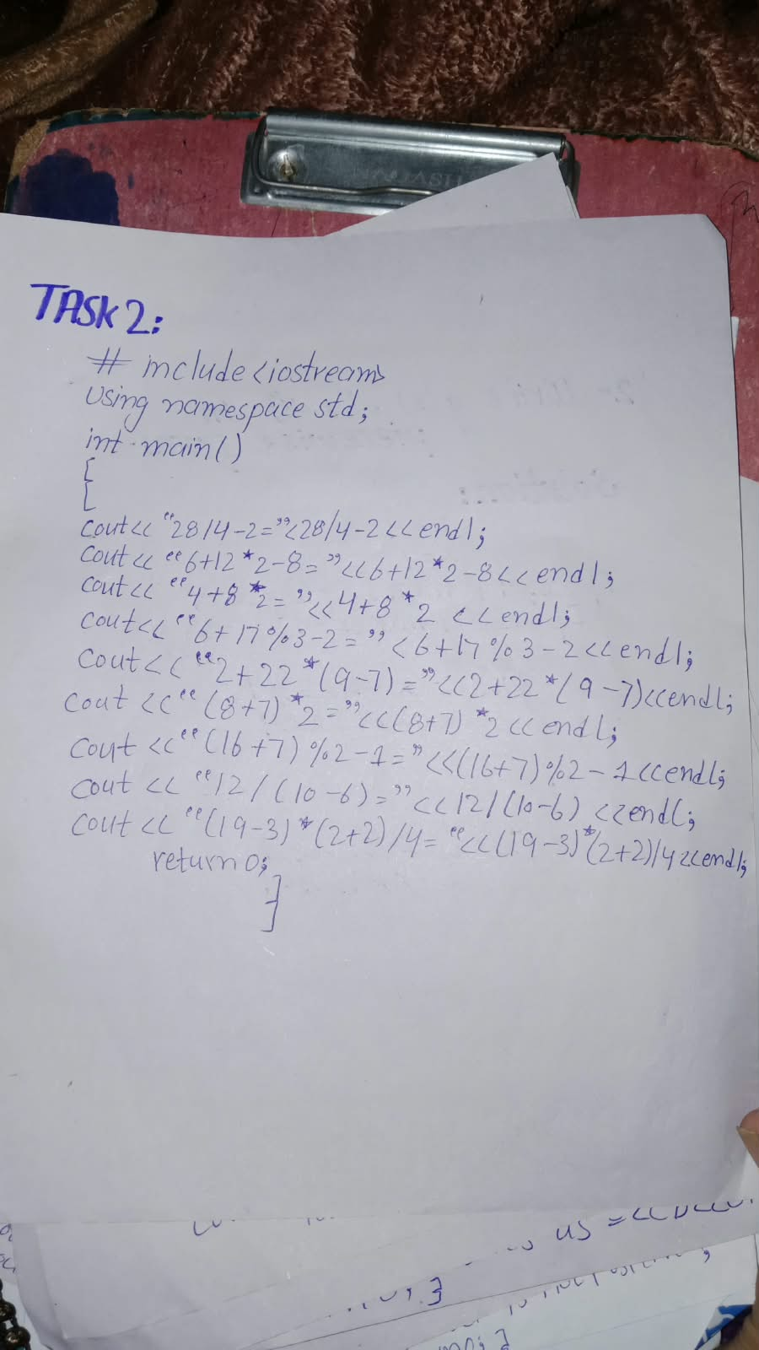

Code Written on desktop/phone
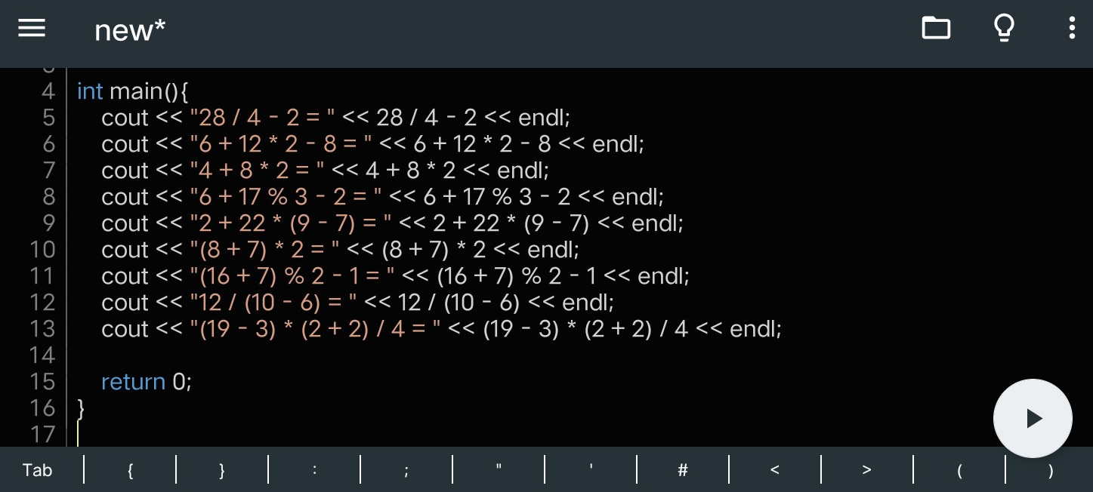

Code Output
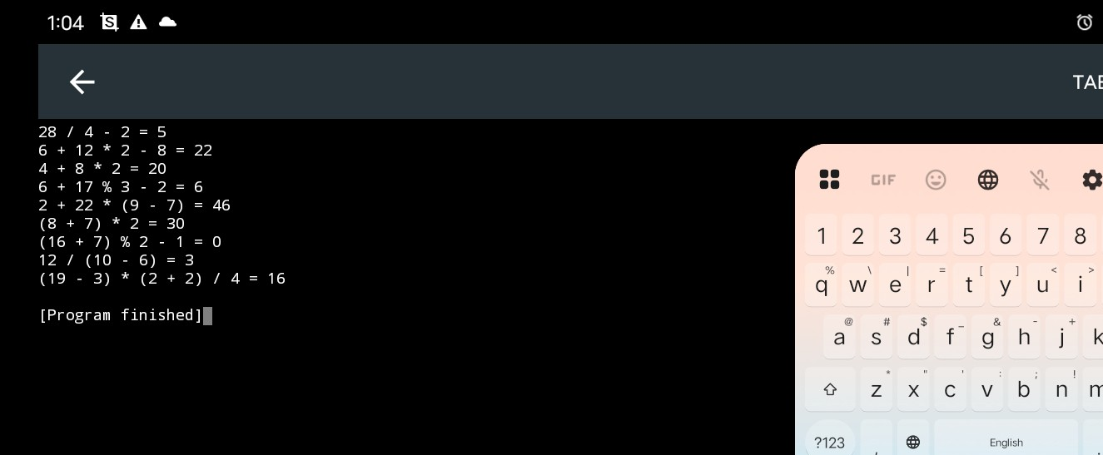

TASK 3
Handwritten Code
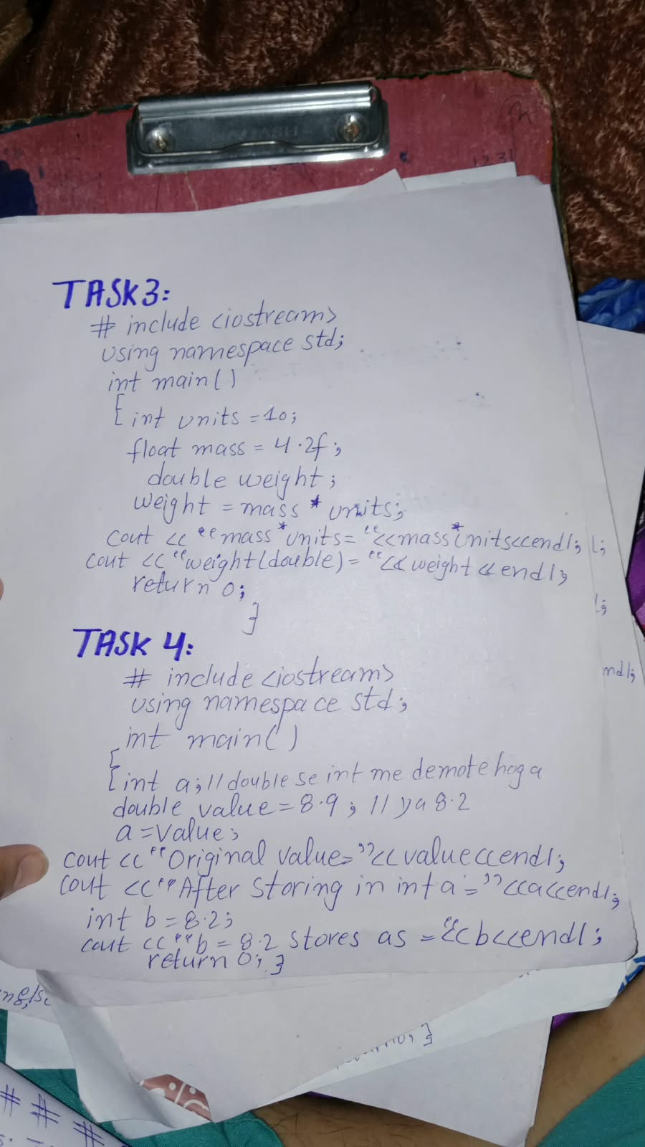
Code Written on desktop/phone
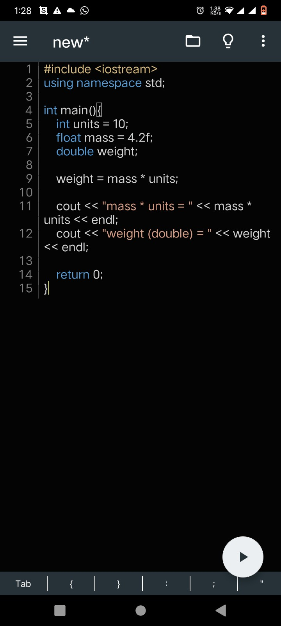

Code Output
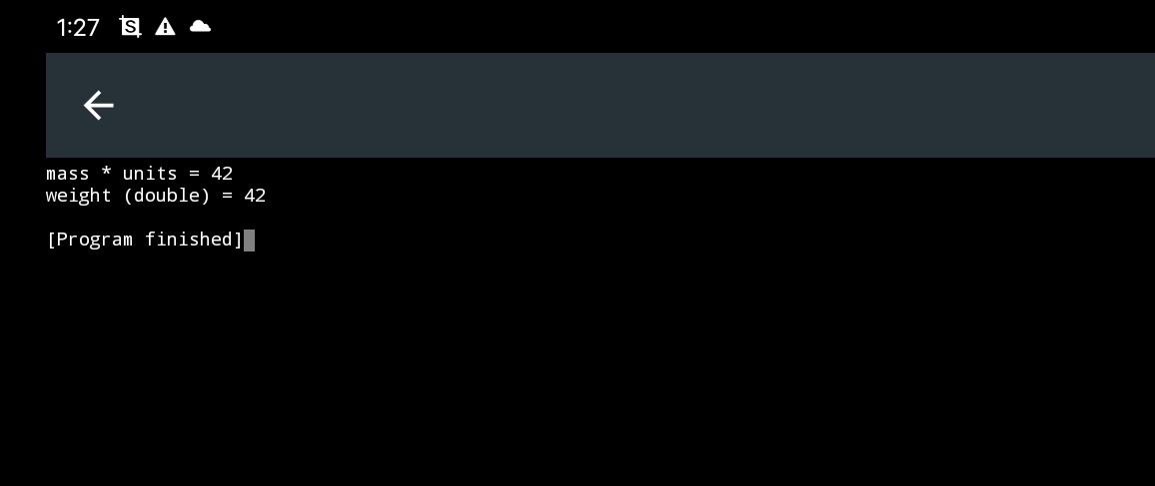
TASK 4
Handwritten Code

Code written on phone/desktop

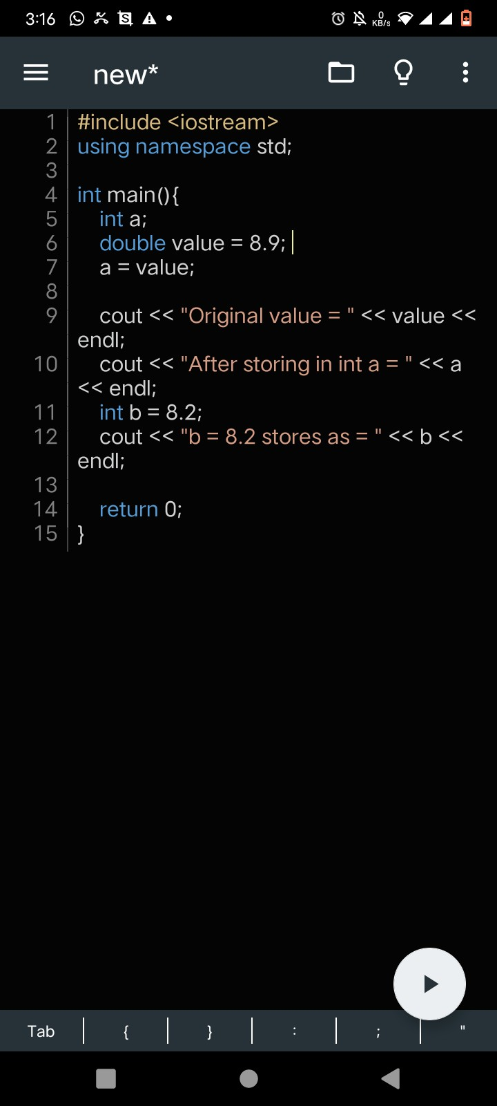

Code Output
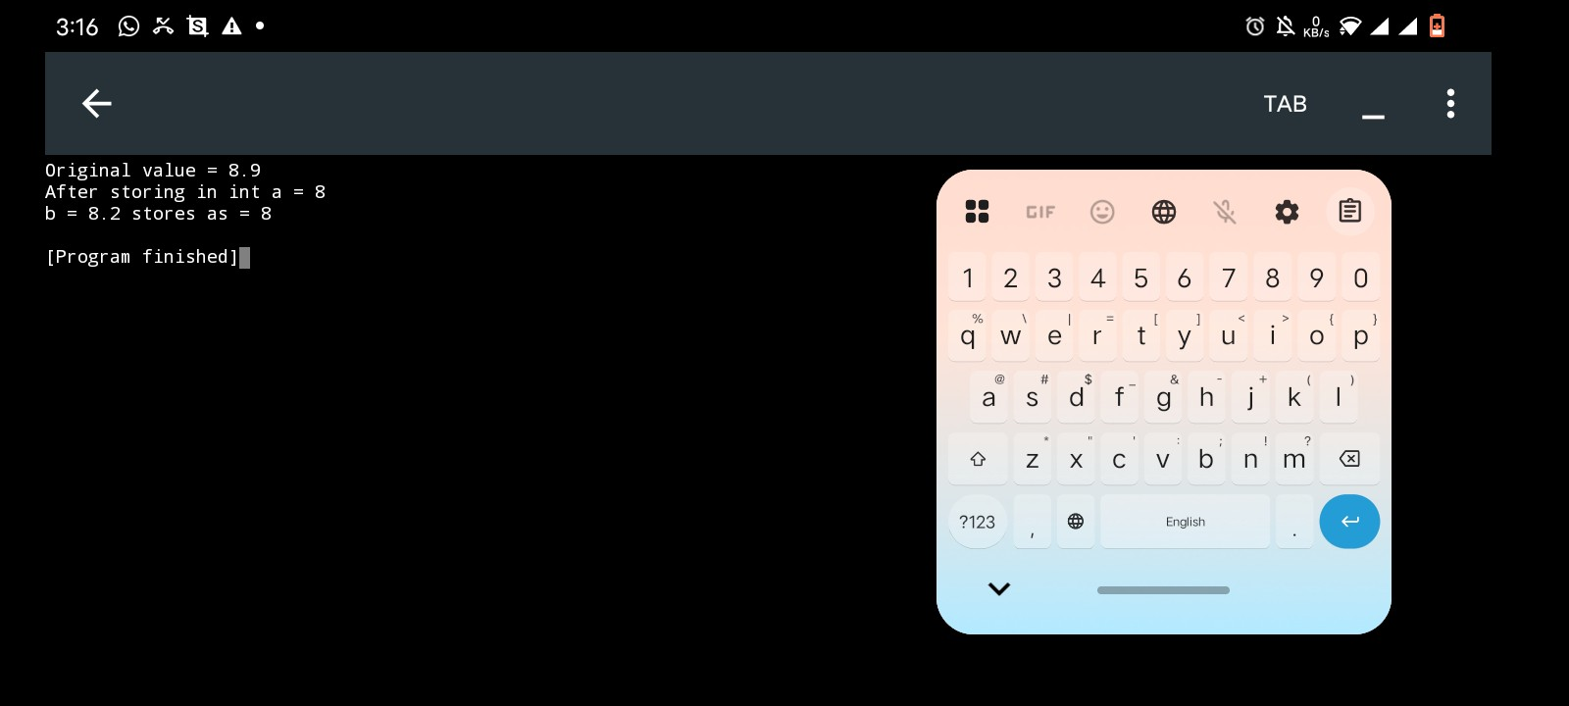
TASK 5
Handwritten Code
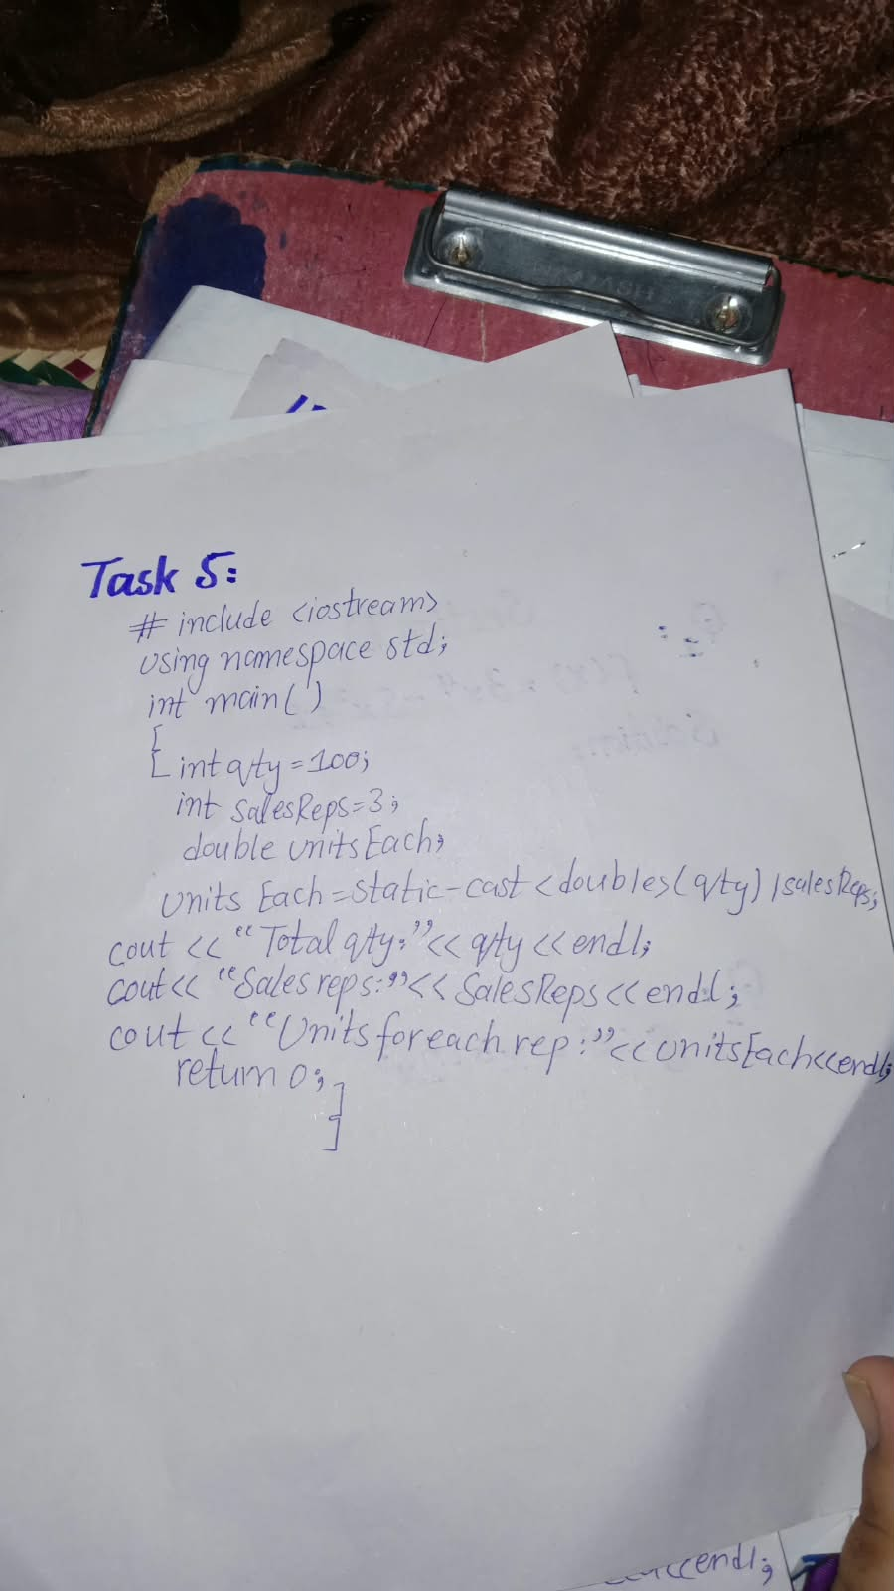
Code Written on phone/desktop
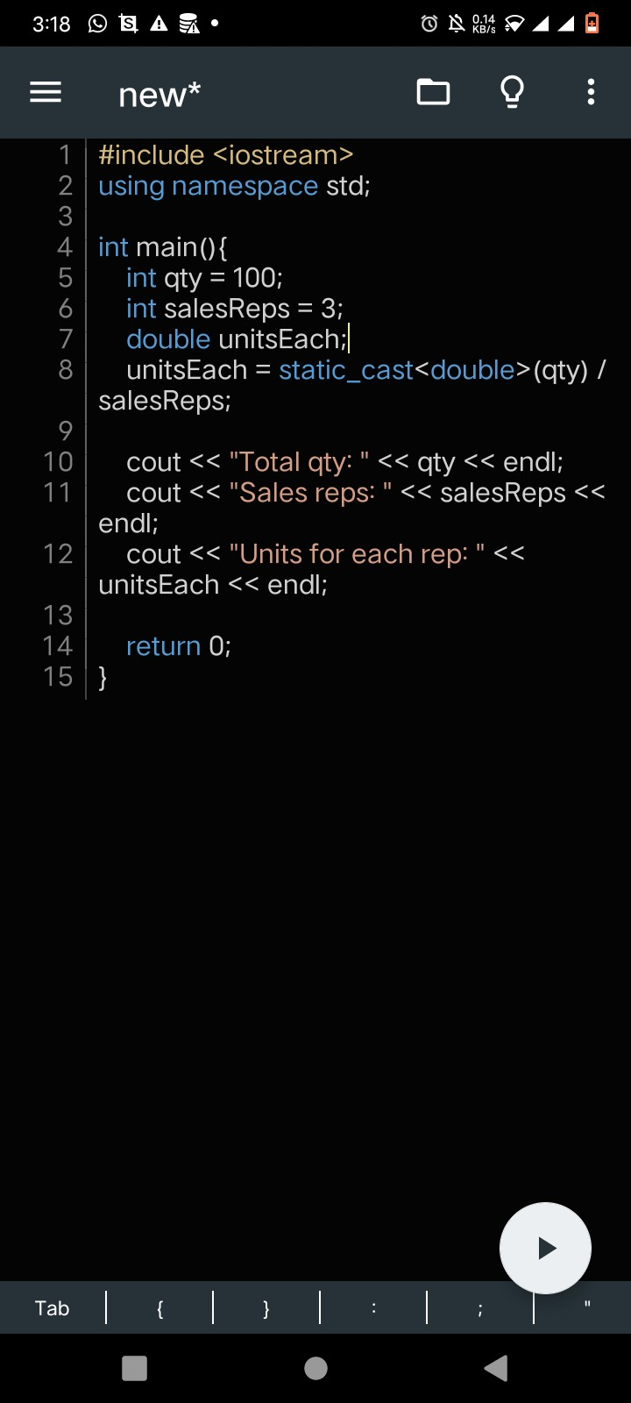

Code Output
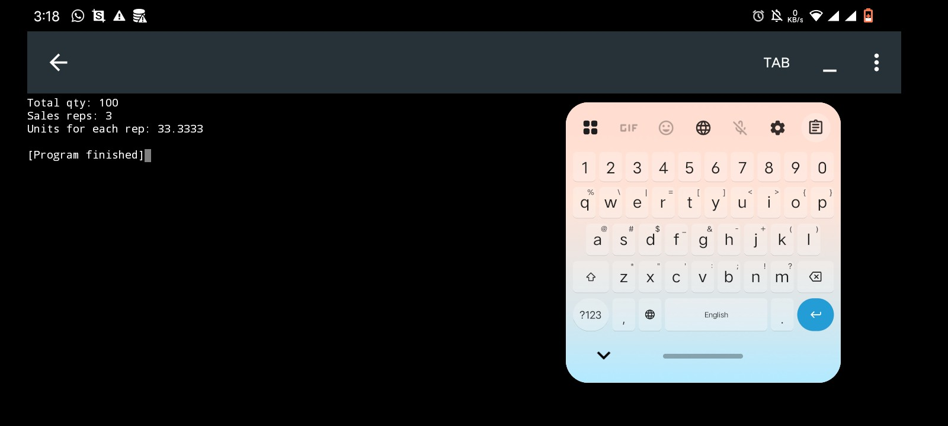
TASK 6
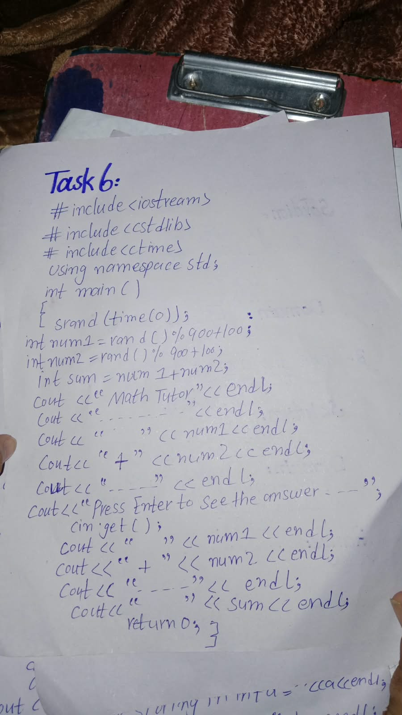

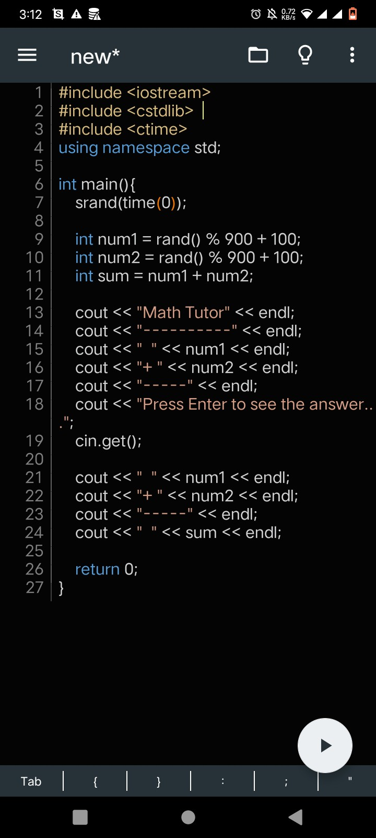
Code Written On phone/desktop
Code Output
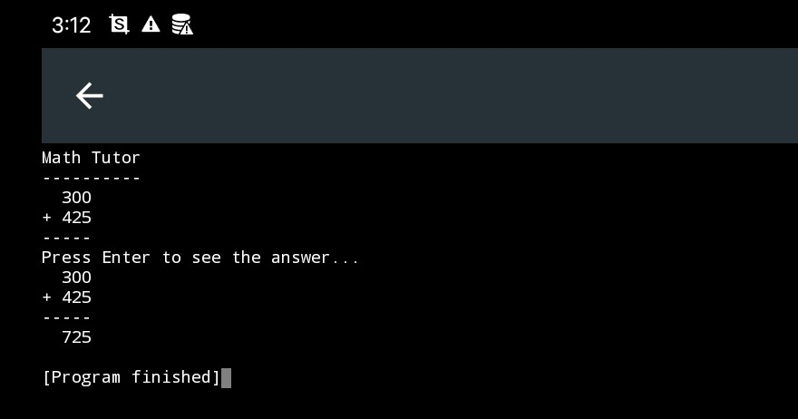

Home Task 1
(a)
Handwritten Code
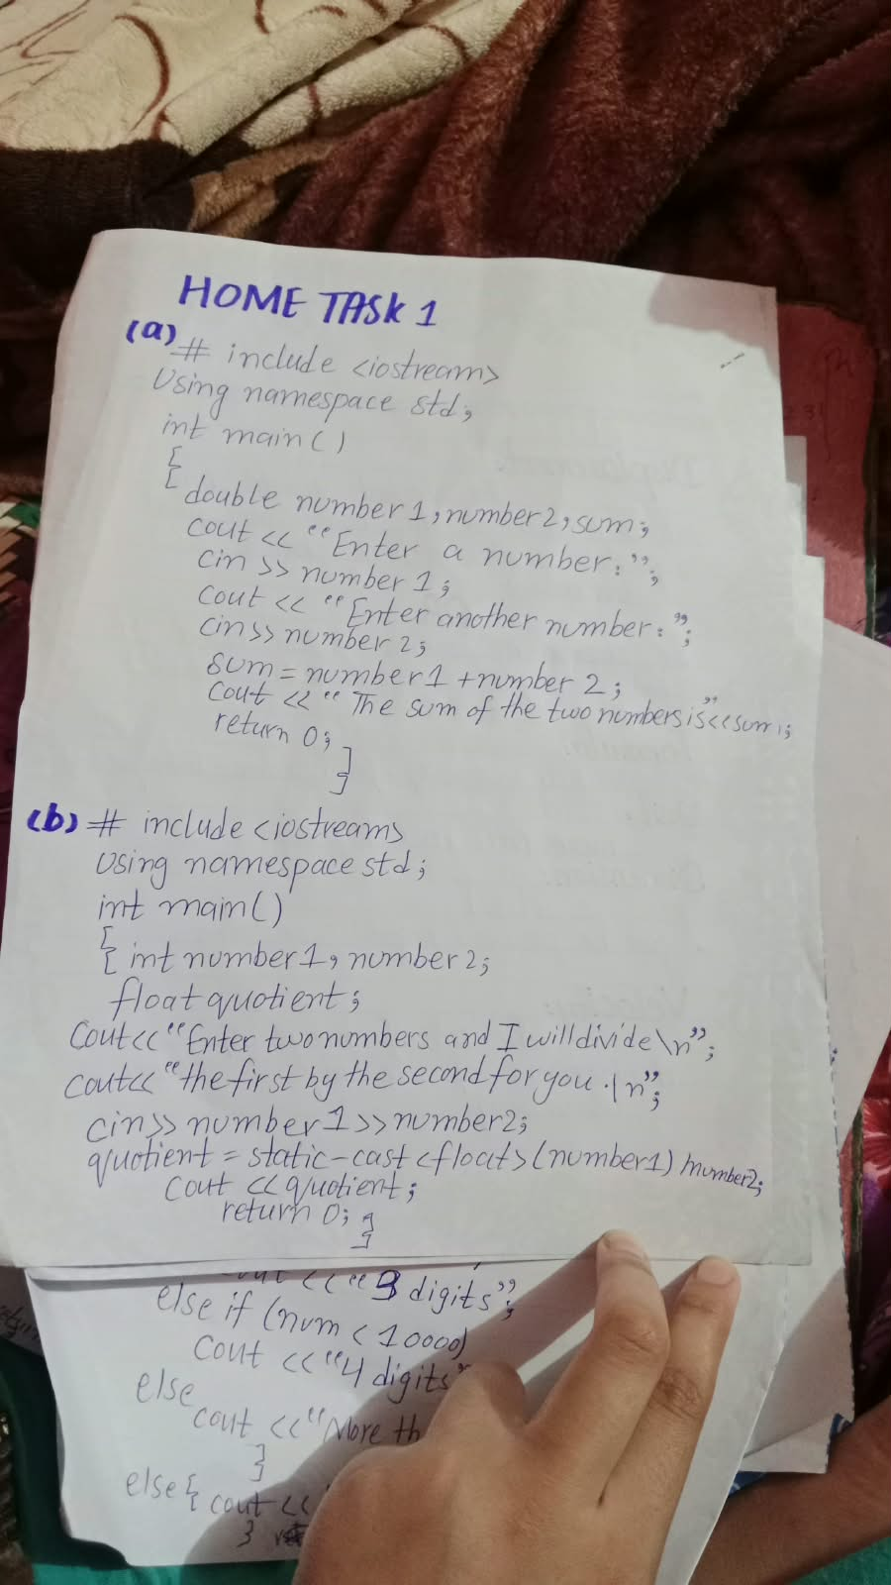
Code Written on phone/desktop
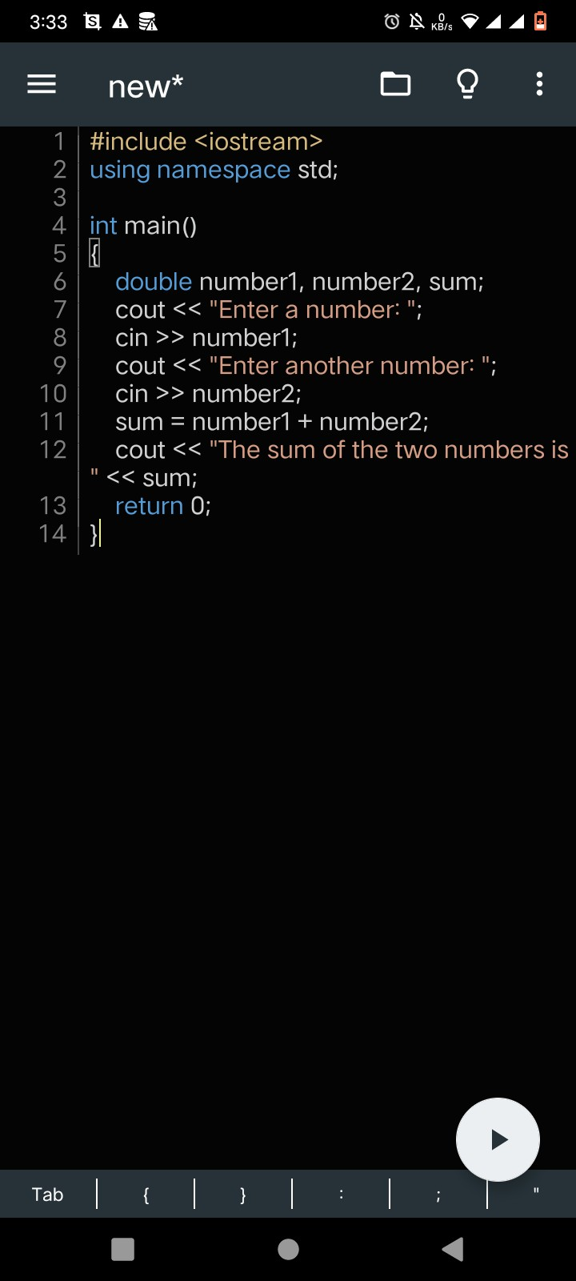
Code Output

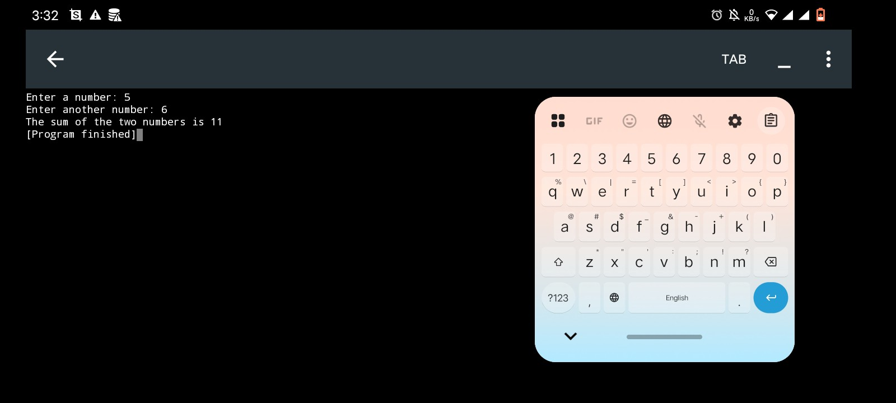

(b)
Handwritten Code
Code Written on phone/desktop
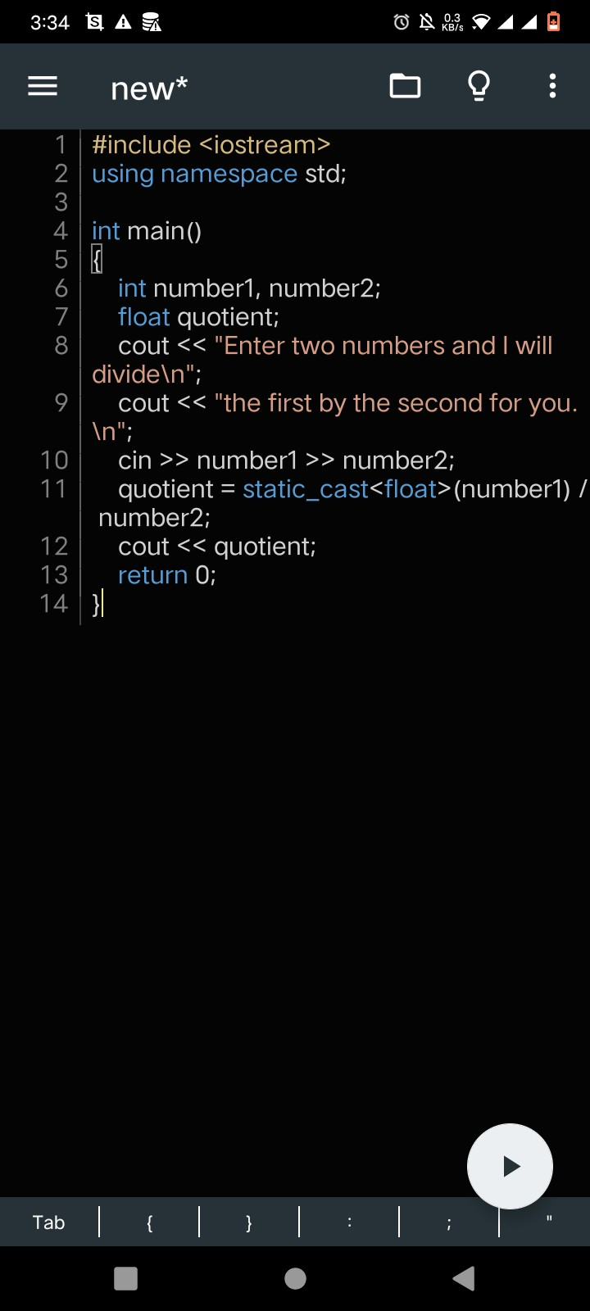
Code Output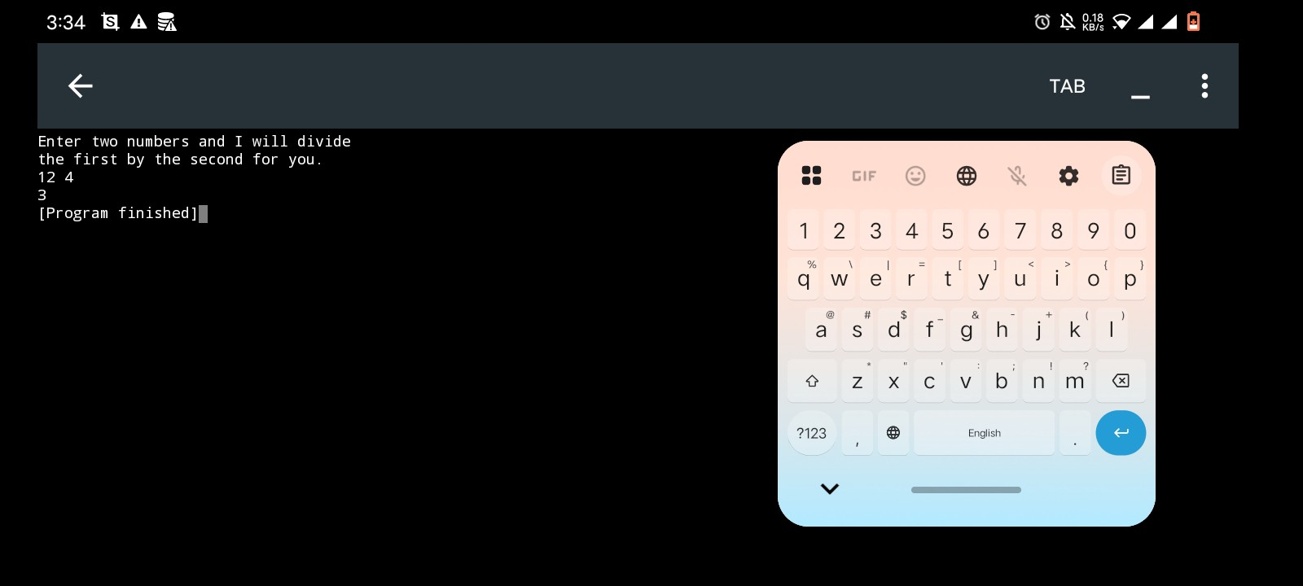
Home Task 2
Handwritten Code
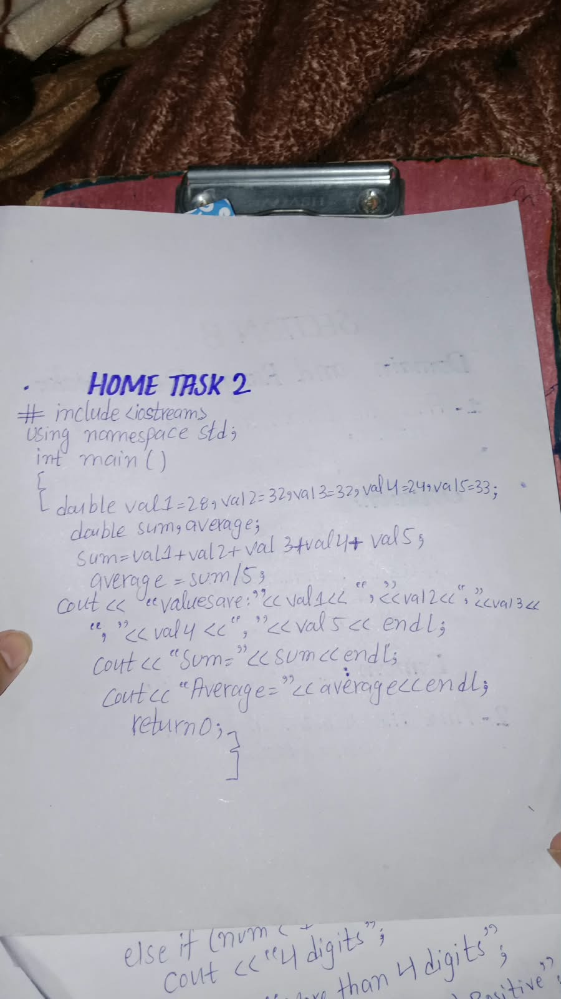

Code Written on phone/desktop
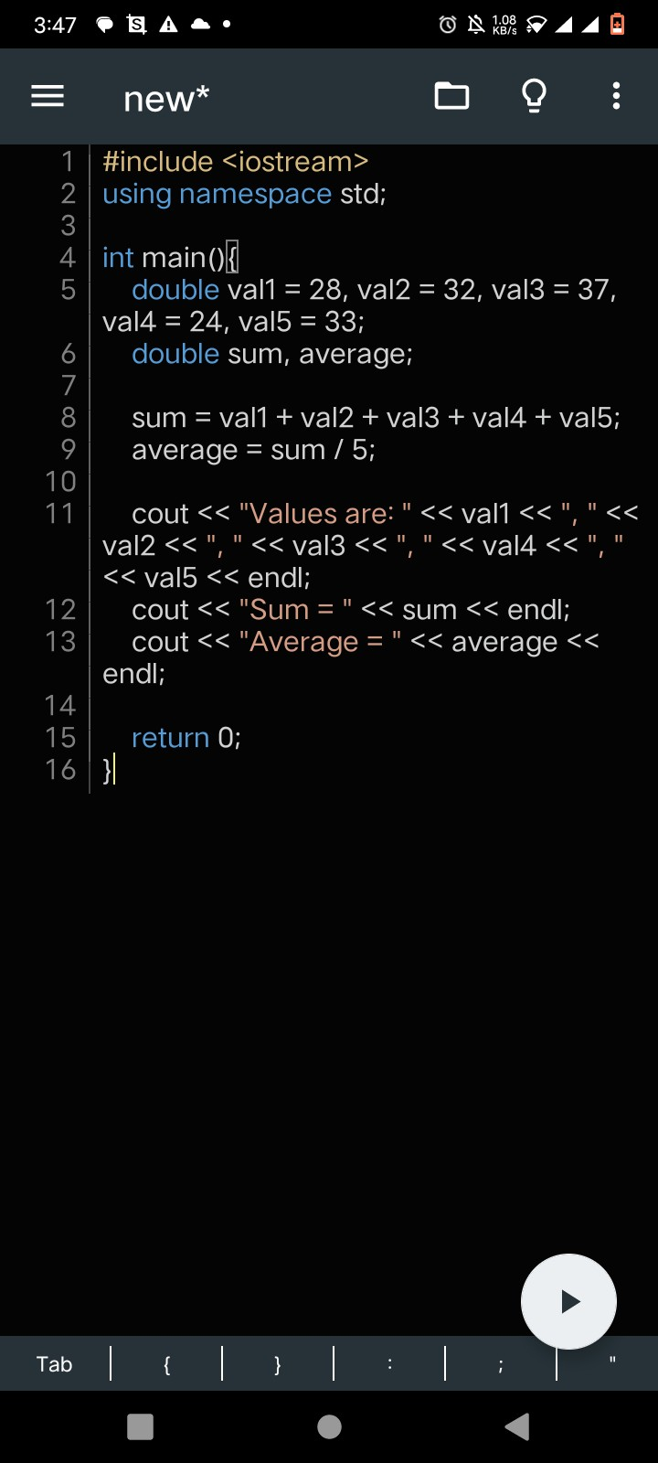
Code Output
